CHAPTER 1
Exploratory Data Analysis

- The terms bit, short for binary digit
> Elements of Structured Data
- There are two basic types of structured data: numeric and categorical
> Numeric
- Data that are expressed on a numeric scale.
- Continuous
Data that can take on any value in an interval. (Synonyms: interval, float, numeric)
- Discrete
Data that can take on only integer values, such as counts. (Synonyms: integer, count)
> Categorical
- Data that can take on only a specific set of values representing a set of possible categories.
(Synonyms: enums, enumerated, factors, nominal)
- Binary
A special case of categorical data with just two categories of values, e.g., 0/1, true/false. (Synonyms: dichotomous, logical, indicator, boolean)
- Ordinal
Categorical data that has an explicit ordering. (Synonym: ordered factor)
+ Link
https://whatagraph.com/blog/articles/discrete-vs-continuous-data - Defination
https://www.voxco.com/blog/categorical-data-vs-numerical-data/
https://www.w3schools.com/sql/sql_datatypes.asp - Data Type
> Rectangular Data
- a spreadsheet or database table.
- Rectangular data is the general term for a two-dimensional matrix with rows indicating records (cases) and columns indicating features (variables)
- Data frame
Rectangular data (like a spreadsheet) is the basic data structure for statistical and machine learning models.
- Feature
A column within a table is commonly referred to as a feature.
Synonyms - attribute, input, predictor, variable
- Outcome
Many data science projects involve predicting an outcome often a yes/no outcome. The features are sometimes used to predict the outcome in an experiment or a study.
Synonyms - dependent variable, response, target, output
- Records
A row within a table is commonly referred to as a record.
Synonyms - case, example, instance, observation, pattern, sample
> Data Frames and Indexes
Terminology for rectangular data
A statistician, predictor variables are used in a model to predict a response or dependent variable.
A data scientist, features are used to predict a target.

> Nonrectangular Data Structures
Graph (or network) data structures are used to represent physical, social, and abstract relationships.
- Graphs in Statistics
In computer science and information technology, the term graph typically refers to a depiction of the connections among entities, and to the underlying data structure.
In statistics, graph is used to refer to a variety of plots and visualizations
> Estimates of Location
- Variables with measured or count data might have thousands of distinct values. A basic step in exploring your data is getting a "typical value" for each feature (variable): an estimate of where most of the data is located (i.e., its central tendency).
- Statisticians often use the term estimate for a value calculated from the data at hand, Data scientists and business analysts are more likely to refer to such a value as a metric.

- Mean
The sum of all values divided by the number of values.
You will encounter the symbol x (pronounced "x-bar")
Synonym – average
The formula to compute the mean for a set of n values x 1 , x 2 , ..., x n is:
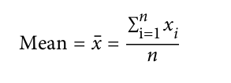

- N (or n) refers to the total number of records or observations. In statistics it is capitalized if it is referring to a population, and lower-case if it refers to a sample from a population. In data science, that distinction is not vital, so you may see it both ways.

- the mean is much more sensitive to the data, there are many instances in which the median is a better metric for location
- Weighted mean
The sum of all values times a weight divided by the sum of the weights.
Synonym - weighted average

- Median
The value such that one-half of the data lies above and below.
Synonym - 50th percentile
Example - Let's say we want to look at typical household incomes in neighborhoods around Lake Washington in Seattle. In comparing the Medina neighborhood to the Windermere neighborhood, using the mean would produce very different results because Bill Gates lives in Medina. If we use the median, it won't matter how rich Bill Gates is the position of the middle observation will remain the same.
- Percentile
The value such that P percent of the data lies below. The value such that P percent of the values take on this value or less and (100-P) percent take on this value or more.
Synonym - quantile
- Weighted median
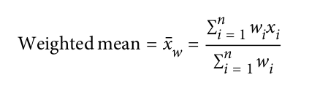
The value such that one-half of the sum of the weights lies above and below the sorted data.
Another type of mean is a weighted mean,
which you calculate by multiplying each
data value x_{i} by a user-specified weight w_{i} and
dividing their sum by the sum of the
weights. The formula for a weighted mean is:

- Trimmed mean
The average of all values after dropping a fixed number of extreme values.
Synonym - truncated mean
Representing the sorted values by x 1 , x 2 , ..., x n where x 1 is the smallest value
and x n the largest, the formula to compute the trimmed mean with p smallest and
largest values omitted is:
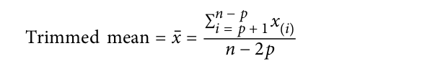

- Robust
Not sensitive to extreme values.
Synonym - resistant

- Outlier
A data value that is very different from most of the data.
Synonym - extreme value
- When outliers are the result of bad data, the mean will result in a poor estimate of location, while the median will still be valid. In any case, outliers should be identified and are usually worthy of further investigation.
- The basic metric for location is the mean, but it can be sensitive to extreme values (outlier).
- Other metrics (median, trimmed mean) are less sensitive to outliers and unusual distributions and hence are more robust.
> Estimates of Variability
- Deviations
The difference between the observed values and the estimate of location.
Synonyms - errors, residuals
- Variance
The sum of squared deviations from the mean divided by n - 1 where n is the number of data values.
Synonym - mean-squared-error
- Standard deviation
The square root of the variance.
- Mean absolute deviation
The mean of the absolute values of the deviations from the mean.
Synonyms - l1-norm, Manhattan norm
- Median absolute deviation from the median
The median of the absolute values of the deviations from the median.
- Range
The difference between the largest and the smallest value in a data set.
- Order statistics
Metrics based on the data values sorted from smallest to biggest.
Synonym - ranks
- Interquartile range
The difference between the 75th percentile and the 25th percentile.
Synonym - IQR
> Standard Deviation and Related Estimates
- These deviations tell us how dispersed the data is around the central value.
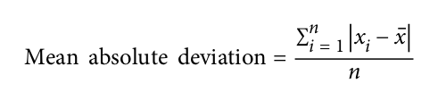

where x is the sample mean.
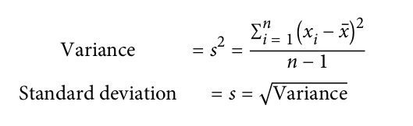

- Degrees of Freedom, and n or n - 1?
- A robust estimate of variability is the median absolute deviation from the median or
MAD:
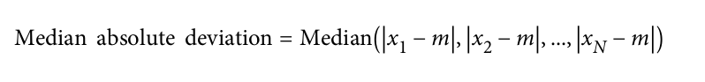

where m is the median. Like the median, the MAD is not influenced by extreme values.
> Estimates Based on Percentiles
- Statistics based on sorted (ranked) data are referred to as order statistics.
- The most basic measure is the range: the difference between the largest and smallest numbers
- Note that the median is the same thing as the 50th percentile.
- The percentile is essentially the same as a quantile, with quantiles indexed by fractions (so the .8 quantile is the same as the 80th percentile).

- https://www.r-bloggers.com/2013/08/absolute-deviation-around-the-median/

> Exploring the Data Distribution
- Boxplot
A plot introduced by Tukey as a quick way to visualize the distribution of data.
Synonym - box and whiskers plot
- Frequency table
A tally of the count of numeric data values that fall into a set of intervals (bins).
- Histogram
A plot of the frequency table with the bins on the x-axis and the count (or proportion) on the y-axis. While visually similar, bar charts should not be confused with histograms.
- Density plot
A smoothed version of the histogram, often based on a kernel density estimate.
- In statistical theory, location and variability are referred to as the first and second moments of a distribution. The third and fourth moments are called skewness and kurtosis. Skewness refers to whether the data is skewed to larger or smaller values, and kurtosis indicates the propensity of the data to have extreme values. Generally, metrics are not used to measure skewness and kurtosis; instead, these are discovered through visual displays

> Exploring Binary and Categorical Data
- Mode
The most commonly occurring category or value in a data set.
- Expected value
When the categories can be associated with a numeric value, this gives an average value based on a category's probability of occurrence.
- Bar charts
The frequency or proportion for each category plotted as bars.
- Pie charts
The frequency or proportion for each category plotted as wedges in a pie.
• Expected Value, Probability,
> Correlation
- Correlation coefficient
A metric that measures the extent to which numeric variables are associated with one another ranges from -1 to +1). 0 indicates no correlation.
Like the mean and standard deviation, the correlation coefficient is sensitive to outliers in the data.

- Correlation matrix
A table where the variables are shown on both rows and columns, and the cell values are the correlations between the variables.

- Scatterplot
A plot in which the x-axis is the value of one variable, and the y-axis the value of another.
> Exploring Two or More Variables
- Familiar estimators like mean and variance look at variables one at a time
(univariate analysis). Correlation analysis is an important method that compares two variables (bivariate analysis). estimates and plots, and at more than two variables (multivariate analysis).
- Contingency table
A tally of counts between two or more categorical variables.
- Hexagonal binning
A plot of two numeric variables with the records binned into hexagons.
- Contour plot
A plot showing the density of two numeric variables like a topographical map.
- Violin plot
Similar to a boxplot but showing the density estimate.
- Heat maps, hexagonal binning, and contour plots all give a visual representation of a two-dimensional density.

+ Further Reading
- https://statistics.laerd.com/statistical-guides/measures-central-tendency-mean-mode-median.php
- https://sciencing.com/end-number-mean-7430704.html - For Scientific notation E/e
- http://youtube.com/watch?v=s7WTQ0H0Acc - Estimates of Variability - Variance
+ Using Code Examples
https://github.com/gedeck/practical-statistics-for-data-scientists

